**Mr. Akins Enterprises**

*...you are our priority*

**Business Insights & Strategic Recommendations**

Prepared for:  
Mr. Akintola Suleiman  
Date: May 2025

**Prepared by:  
Abdulqaniyu Sodeeq Adebayo  
Data Analyst**

[**sodeeqadebayo1@gmail.com**](mailto:sodeeqadebayo1@gmail.com)

# Executive Summary

This analysis provides data-driven insights to support strategic business decisions for Mr. Akin Enterprises. It focuses on four key areas:

1. **Targeted Advertising**: Identifying top-performing products by region to optimize Facebook ad campaigns.
2. **After-Purchase Recommendations**: Analyzing purchase behavior to enhance the after-sales experience with personalized product suggestions.
3. **Product Bundling and Cross-Selling**: Uncovering frequently purchased product combinations to inform bundling opportunities and boost sales.
4. **Business Performance Overview**: Presenting clear metrics on revenue, costs, profits, and stock levels, along with a regional performance breakdown.

The findings aim to enhance marketing effectiveness, improve customer satisfaction, and support data-driven inventory and sales strategies.

# Business Overview

Mr. Akin Enterprises is a growing online retailer specializing in clothing and footwear in Nigeria. With operations expanding across multiple regions, the business is now seeking to leverage to enhance decision-making and scale effectively.

**Business Goals:**

* Launch targeted Facebook advertising campaigns by identifying top-selling products in each region.
* Improve the post-purchase experience by offering personalized product recommendations.
* Explore opportunities for bundling and cross-selling by analyzing product combinations frequently bought together.
* Gain a comprehensive view of business performance, including revenue, costs, profits, and stock levels.
* Understand regional performance to better allocate marketing and operational resources.

**Key Challenges:**

* Lack of clarity on which products are most popular in specific regions.
* Limited insight into customer behavior patterns for effective recommendation strategies.
* Unidentified product pairings that could be leveraged for bundling or promotional offers.
* Need for a centralized view of financial and operational metrics to support strategic planning.

By addressing these challenges through data analysis, Mr. Akin Enterprises aims to drive growth, improve customer engagement, and make informed business decisions

# Data Overview & Methodology

**Data Overview & Methodology**

**Dataset Used:**The analysis is based on Mr. Akin Enterprises’ sales dataset, which includes detailed records of online transactions. The dataset spans from 2023 to 2025 and covers product details, pricing, quantity sold, revenue, costs, regional data, and customer purchase behavior.

***Tools Applied:***

* SQL (Structured Query Language): Used to filter and analyze the data. Queries were developed to extract insights on product performance, customer trends, and regional metrics.
* Excel: Used for additional calculations, and data cleaning.
* ChatGPT (AI) : For data visualization.

***Key Performance Indicators (KPIs) Analyzed:***

* Total Revenue
* Total Cost & Profit
* Quantity Sold by Product and Region
* Top-Selling Products per Region
* Frequently Bought Together Items
* Customer Purchase Patterns
* Stock Levels
* Regional Sales Performance

This methodology supports the generation of actionable insights to guide marketing, inventory, and sales strategies.

# Key Insights

**Business Performance and Overview Analysis :**

**Overall:**

Total Revenue: ₦364.8 million

Total Cost: ₦246.8 million

Net Profit: ₦118 million

Profit Margin: 54.75%

Units Sold: 9,965

Units in Stock: 5,370

**What this tells us:**

A Revenue of 364.8 million naira ( **364,819,805)** was generated which reflects strong revenue generation. A total of 246.8 million naira ( **246,802,271**) was spent, and a profit of 118.017 million naira ( **118,017,533** ) was made genarating a profit margin of **54.73%** suggesting a strong bussiness. A total **9,965** stocks are sold with **5,370** stocks remaining in the store as for 2025-01-01.

**Regional:**

|  |  |  |  |  |  |
| --- | --- | --- | --- | --- | --- |
| state | Revenue | Profit | Profit_margin | Quantity_sold | %ageOfQuantitySold |
| Lagos | 37990044 | 25069232.55 | 65.99% | 1000 | 39.68% |
| Osun | 18946234 | 12703806.41 | 67.05% | 492 | 19.52% |
| Oyo | 15852143 | 11082829.06 | 69.91% | 441 | 17.50% |
| Ondo | 7277012 | 4677484.78 | 64.28% | 219 | 8.69% |
| Kaduna | 4930201 | 3242826.98 | 65.77% | 135 | 5.36% |
| Enugu | 4400336 | 2793504.08 | 63.48% | 120 | 4.76% |
| Edo | 4126247 | 2911502.71 | 70.56% | 113 | 4.48% |

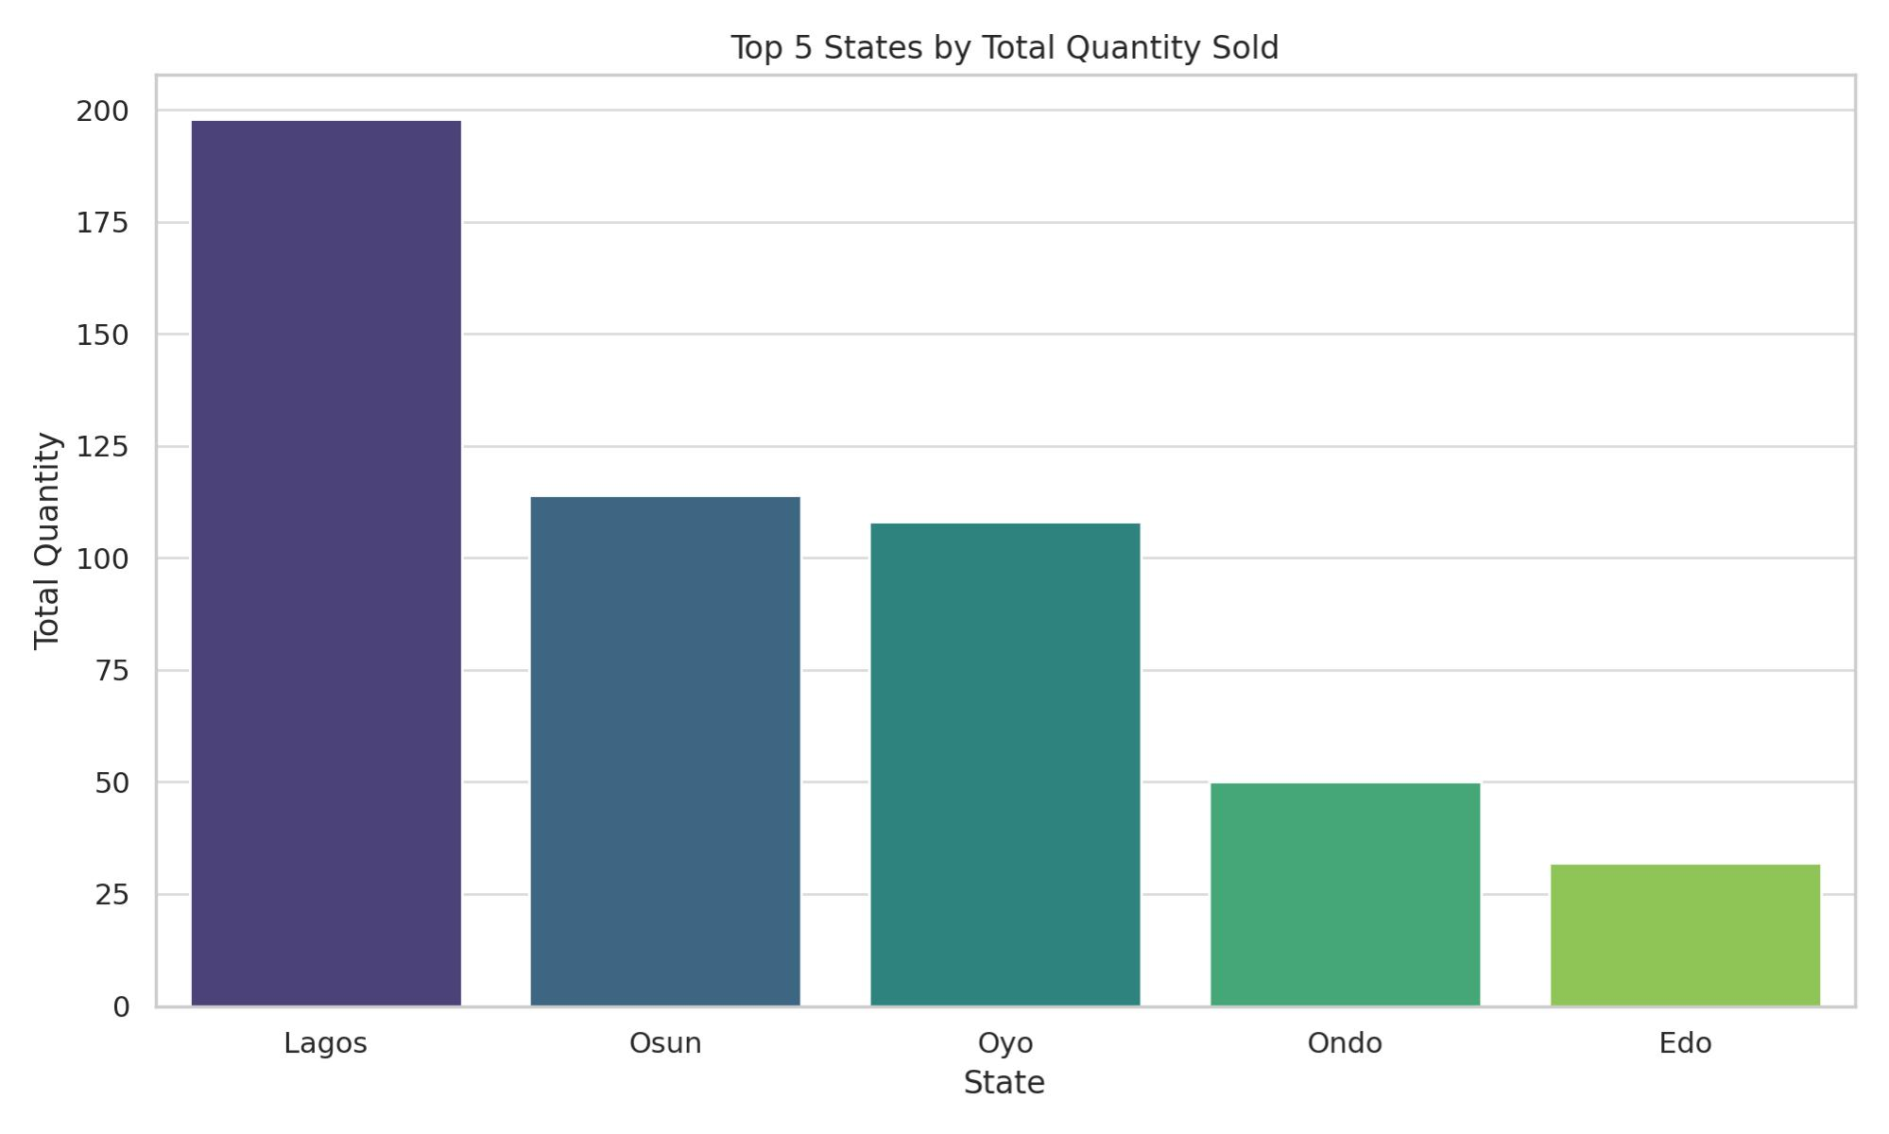

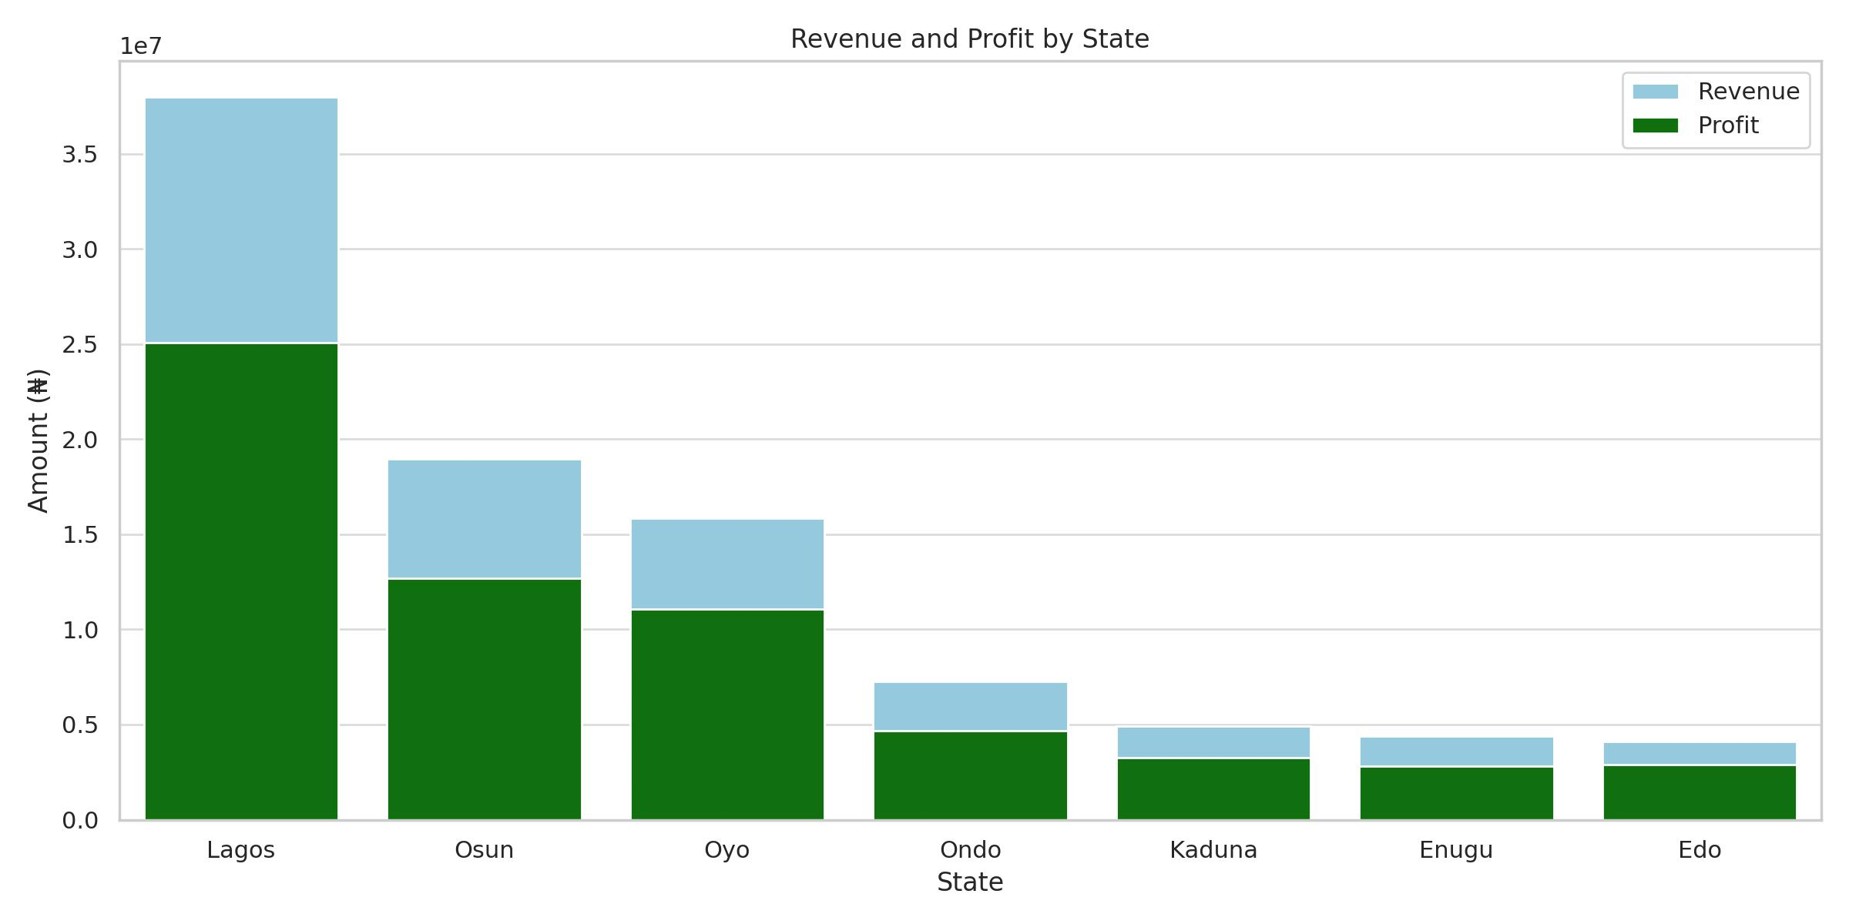**Lagos** has the highest sales and profit, selling **1000** units and making **₦38 million** in revenue with a **66% profit margin.**

**Oyo** and **Edo** have the best profit margins (around 70%), even though they sell fewer units.

**Osun** is second in sales and profit, with good profit margins too.

Other states like **Ondo**, **Kaduna**, and **Enugu** sell less but still make good profits.

**Lagos** can increase profit by cutting costs, and smaller states with good margins could grow their sales.

***What does this tell us?***

Lagos is the main market driving most sales and profit, but there is room to improve its profit margin. States with fewer sales but higher margins show they sell more profitably per unit and could grow if given more focus. Overall, balancing volume and profit margin across states can help increase total profitability.

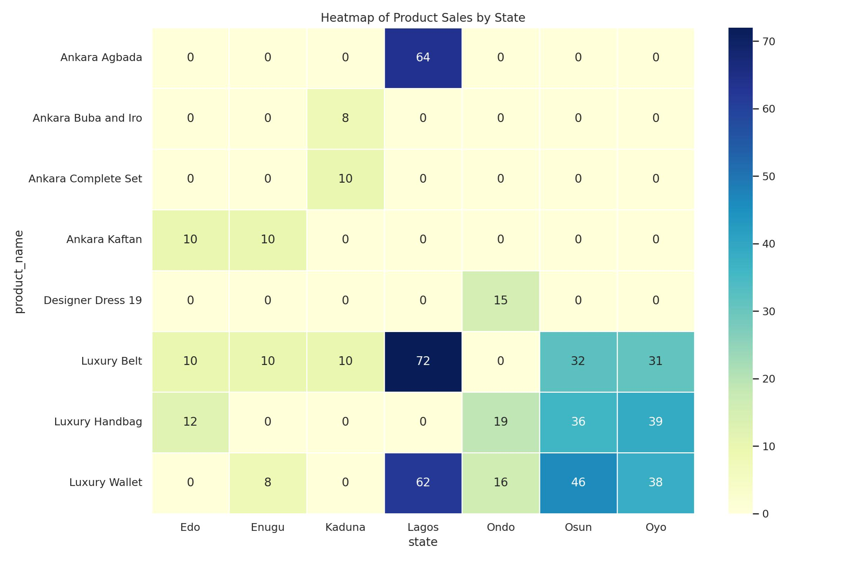**Targeted Advertising Analysis:**

|  |  |  |  |
| --- | --- | --- | --- |
| state | product_name | Total_Quantity | Ranks |
| Edo | Luxury Handbag | 12 | 1 |
| Edo | Luxury Belt | 10 | 2 |
| Edo | Ankara Kaftan | 10 | 3 |
| Enugu | Luxury Belt | 10 | 1 |
| Enugu | Ankara Kaftan | 10 | 2 |
| Enugu | Luxury Wallet | 8 | 3 |
| Kaduna | Luxury Belt | 10 | 1 |
| Kaduna | Ankara Complete Set | 10 | 2 |
| Kaduna | Ankara Buba and Iro | 8 | 3 |
| Lagos | Luxury Belt | 72 | 1 |
| Lagos | Ankara Agbada | 64 | 2 |
| Lagos | Luxury Wallet | 62 | 3 |
| Ondo | Luxury Handbag | 19 | 1 |
| Ondo | Luxury Wallet | 16 | 2 |
| Ondo | Designer Dress 19 | 15 | 3 |
| Osun | Luxury Wallet | 46 | 1 |
| Osun | Luxury Handbag | 36 | 2 |
| Osun | Luxury Belt | 32 | 3 |
| Oyo | Luxury Handbag | 39 | 1 |
| Oyo | Luxury Wallet | 38 | 2 |
| Oyo | Luxury Belt | 31 | 3 |

Luxury Belt is the top-performing product in Lagos, Enugu, and Kaduna, indicating strong cross-regional appeal.

Luxury Handbag leads in Edo, Ondo, Osun, and Oyo, showing high demand in South-Western states.

Luxury Wallet consistently ranks 2nd or 3rd across several states, highlighting stable demand and cross-selling potential.

**What does this tells us? :**

People in different states like different products, so ads should be made to match each region.

Luxury items like belts, handbags, and wallets are the most wanted in many places. These should be the main focus of ads.

Traditional clothes like Ankara are also popular, especially in some regions. Including them in ads will attract more buyers.

Some items, like belts and wallets, are often bought together. These can be sold as a bundle to increase sales.

**After-Purchase Recommendation Analysis:**

*Get the full table of this analysis here ([RFM_Result_Table](https://1drv.ms/x/c/98f0fd831a51af68/Ef39PTnQtxJCr_RGE7BYe9IBEBcFhwQ3i6nOpLUymRg60g?e=kKtPNU) )*

1. **Customer segmentation:** RFM analysis reveals distinct customer segments, including New & Developing Customers, Strategic Focus Customers, Mid Value One Time Buyers, Core Regular Customers, High Potential But Dormant Customers, and Lost Customers.

2. **High-value customers**: *Strategic Focus Customers* (RFM scores: 144, 244, 344, 444) are high-value customers who deserve personalized attention and retention strategies.

3. **Dormant customers:** High Potential But Dormant Customers (RFM scores: 311, 322, 333) have potential for re-engagement through targeted win-back campaigns.

4. **Lost customers:** Lost Customers (RFM scores: 411, 422, 433) require surveys or incentives to understand their reasons for leaving and potentially win them back.

5. **Customer retention:** Core Regular Customers (RFM scores: 222, 233) are loyal customers who deserve retention strategies, such as loyalty rewards and exclusive offers.

6. **New customer acquisition:** New & Developing Customers (RFM score: 111) require nurturing through welcome offers, product recommendations, and loyalty program information.

*For more understanding on RFM Analysis Interpretation* [*click here*](https://1drv.ms/w/c/98f0fd831a51af68/Ebb3vKAG5IdItt0yycJjbZwBLNPFECVZkXyCx2EHoXcx4g?e=Bdn5oC)*.*

**Product Bundling and Cross-Selling Analysis:** 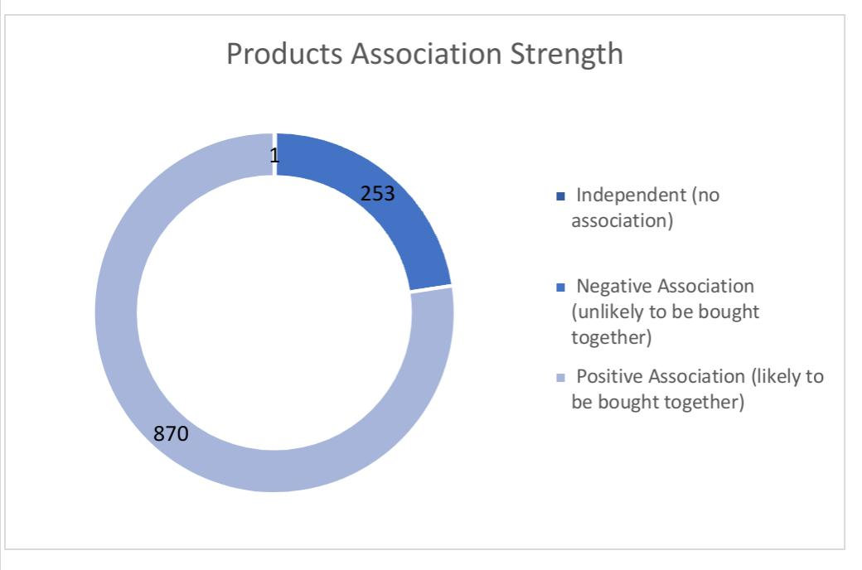

**1. Frequent Item Pairs**

Some items are repeatedly purchased together, such as Luxury Handbag & Luxury Belt (26 times) and Luxury Wallet & Ankara Agbada (22 times).

**2. Rare Purchase Patterns**

All pairs have low support values (<1%), meaning they are bought together infrequently.

**3. Low Confidence Levels**

Most item pairs have low confidence (<10%), indicating that buying one item does not strongly predict buying the other.

**4. Positive and Negative Associations**

Some pairs have high lift ratios (>1), showing a strong positive link (e.g., Luxury Senator & Luxury Belt, Lift = 2.73).

Others have lift ratios below 1, meaning they are unlikely to be purchased together (e.g., Luxury Wallet & Luxury Belt, Lift = 0.99).

**5. Cross-Category Patterns**

Some combinations connect different fashion styles, like Designer Dress & Ankara Agbada (Lift = 1.82), hinting at diverse customer preferences.

**6. Consumer Buying Behavior**

Some pairs show strong natural connections (e.g., Luxury Wallet & Ankara Kaftan, Lift = 1.11), while others have weak associations, meaning they are purchased separately.

To know more about Market Basket Analysis Interpretation, [click here](https://1drv.ms/w/c/98f0fd831a51af68/EQ6w-V8FBd9Mnn6bDu5w5JoBC5eKfSCedgom9oitsVp9Lw?e=LNonn1)

**What Does This Tell Us?**

- The data suggests that while certain product pairs are frequently bought together, overall purchasing behavior remains fragmented with low confidence levels.

- Positive associations indicate potential opportunities for bundling, while negative associations suggest that some items should remain distinct in marketing and retail strategies.

- Cross-category trends highlight unique customer preferences, revealing opportunities for curated product recommendations.

***Get the complete table of the market basket analysis result,*** [***click here***](https://1drv.ms/x/c/98f0fd831a51af68/EV6gRUSR8O9Ptxa1iZC2jIMBJHCSflD3T66TKGJed81rew)***.***

# Recommendations

**1. Implement Region-Specific Advertising**

***- Customize Ad Creatives & Messaging:***

Use proven regional insights to drive targeted Facebook campaigns. For instance, feature the “Luxury Belt” in Lagos, Kaduna, and Enugu ads, while emphasizing “Luxury Handbag” in Edo, Ondo, Osun, and Oyo regions. This will ensure messaging resonates with local preferences.

***- Allocate Budget Based on Regional Performance:***

Prioritize ad spending in regions with high revenue and sales volume while creating growth-oriented campaigns in smaller, high-margin markets. By directing resources where they deliver the best returns, you maximize advertising efficiency.

**2. Upgrade Post-Purchase Engagement**

***- Personalize Customer Touchpoints:***

Utilize the established customer segmentation (e.g., Strategic Focus, Core Regulars, and Dormant Customers) to create tailored follow-up emails and notifications featuring product suggestions pertinent to each segment’s buying behavior. Although segmentation is in place, focus on executing differentiated communication strategies to build stronger customer loyalty.

***- Implement Loyalty Programs and Win-Back Initiatives:***

Initiate reward systems and exclusive offers for frequent buyers while specifically targeting lapsed customers with special incentives. This approach will reinforce the value of the brand and encourage repeat purchases

**3. Refine Product Bundling and Cross-Selling**

***- Develop Attractive Bundled Offers:***

Leverage the frequent pairing of items (such as the Luxury Handbag & Luxury Belt) to create well-priced, bundled offers that simplify decisions for customers. Clear pricing advantages and visual cues can drive uptake and improve overall transaction values.

***- Focus on Complementary Cross-Selling:***

When a customer selects one product, automatically recommend complementary items that align with their past purchase behavior. Ensure that these suggestions are based on observed customer preferences to enhance the buying experience.

**4. Strengthen Operational Focus Through Data-Driven Practices**

***- Monitor Key Performance Metrics:***

Continue to routinely track revenue, cost, profit margins, and regional performance. Amplify focus on optimizing inventory levels based on demand trends to improve stock turnaround and reduce excess inventory.

***- Fine-Tune Cost Management:***

In high-volume regions, review cost structures to pinpoint areas where efficiency gains can further improve margins. Lower operational costs without sacrificing the quality or customer experience.

**Summary**

By executing these region-focused ad strategies, personalized post-purchase communications, smart bundling and cross-selling offers, and maintaining a tight operational handle on costs and inventory, Mr. Akin Enterprises can directly address current challenges and unlock further growth opportunities. These strategies are designed to drive increased customer engagement and profitability in alignment with the insights already observed.

# Conclusion

This report provides clear, data-driven insights to support Mr. Akin Enterprises' goals. By identifying top products by region, understanding customer behavior, and uncovering product pairings, the business can improve marketing, increase customer engagement, and boost sales.

Implementing the recommended strategies—such as region-specific ads, personalized follow-ups, and smart product bundling—will help the business grow efficiently and make more informed decisions moving forward.

# Appendix

All SQL Queries used for the analysis are available via [here](https://github.com/Adebayo-tech/Data-Driven-Business-Strategy-for-Mr.-Akin-Enterprises/blob/46103330fd4865abc085379aabc5d1471b5d0110/Mr.%20Akin%20Analysis.sql)

<https://github.com/Adebayo-tech/Data-Driven-Business-Strategy-for-Mr.-Akin-Enterprises/blob/46103330fd4865abc085379aabc5d1471b5d0110/Mr.%20Akin%20Analysis.sql>

View full project here;

<https://github.com/Adebayo-tech/Data-Driven-Business-Strategy-for-Mr.-Akin-Enterprises>

# Attached Letter

